**18th PPS (Pakistan Physiological Society) International Conference**

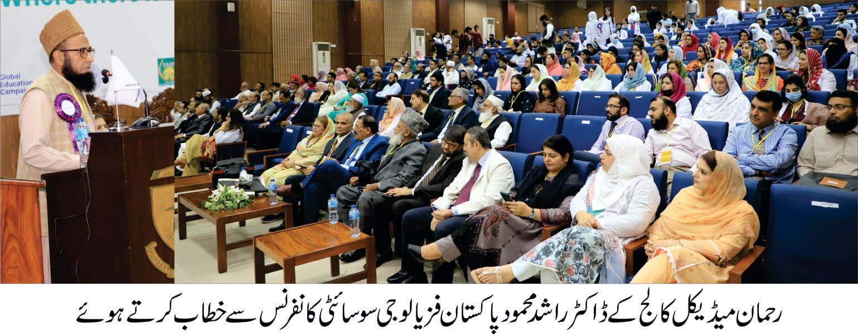

Society: Pakistan Physiological Society

Address: https://pps.org.pk/

Email: pps18.conference@gmail.com

Theme/ title of the Conference: Where there is life, there is Physiology

Dates of the Conference: 6 - 8 October 2023

Conference Venue: Khyber Medical University, Rehman Medical College, & Khyber Girls Medical College, Peshawar, Pakistan

Report prepared by: Prof. Dr. Sundus Tariq (Vice-President SAAP)

**18th PPS (Pakistan Physiological Society) Hybrid International Conference**

The 18th PPS (Pakistan Physiological Society) International Conference was held in Peshawar on October 6, 7 and 8 2023, and featured a wide range of sessions, presentations, and discussions on various aspects of Physiology. The conference was a joint venture by Khyber Medical University, Rehman Medical College, Khyber Girls Medical College, Peshawar, Pakistan. The theme of the conference was “Where there is life, there is Physiology”. The conference aimed to promote and disseminate research and knowledge in the field of Physiology, with a focus on Applied Physiology, Clinical Physiology, AI & Advances in Physiology, Environmental Physiology, Critical & Ethical Training, Medical Education, Research, and the latest advancements. This event was nothing short of a resounding success, and it is evident that meticulous planning and dedication went into making it a memorable experience for all attendees.

The conference brought together a constellation of experts, researchers, and specialists in the field of physiology, fostering a stimulating environment for the exchange of knowledge and the discussion of cutting-edge research findings. It was a hybrid conference that conferred 12 CME points to the conference attendees and 6 CME points each to the participants of the pre-conference workshops. The conference was a huge success as it had more than 500 registered participants. There were 11 pre-conference workshops, 18 plenary presentations, 80 oral presentations, 36 poster presentations and various other model presentations by the scientific community.

**Pre-conference workshops**

The conference was preceded by Pre-conference workshops on 6 October 2023. The 11 workshops included hands on experience on Learning management system, Power-lab, Extended Matching Questions & Cluster Case Multiple-Choice Questions, Nutrition focused physical exam, Scholarly Writing and Citation Management and many more. These workshops not only set the stage for an enriching and productive conference but also demonstrated the level of commitment and excellence that defines our community.

The quality of the content presented during these workshops was truly exceptional. The presenters brought a wealth of knowledge and expertise to the table, delivering engaging and informative sessions that left participants feeling inspired and well-prepared for the main event. The interactive nature of these workshops fostered a sense of collaboration and shared learning that is a testament to our community's spirit.

Moreover, the impeccable organization of these pre-conference workshops cannot be overlooked. The seamless logistics, user-friendly platform, and helpful support staff made it a smooth and enjoyable experience for all participants. This reflects the tremendous effort put forth by the organizing team.

**Opening Ceremony**

The conference day began with an outstanding opening ceremony at Khyber Girls Medical College, where details about the event, pre-conference preparations and future prospects were presented by the President PPS, Prof Dr. Umar Ali Khan and Chairman Organizing Committee, Prof. Dr. Rashid Mahmood. Welcome notes were presented by the presidents/ their representatives of all affiliated societies IUPS, APS, FAOPS and SAAP.

Keynote address was delivered by Major Gen® Prof. Dr. Muhammad Aslam, Advisor, Shifa Tameer e Millat University, Islamabad, where he beautifully explained about the conference theme, “Where there is life, there is Physiology”. He was also awarded lifetime achievement award by the galaxy of Physiologists who gathered to pay tribute to an extraordinary individual whose lifetime of dedication and contributions to the field of Physiology has left an indelible and lasting impact.

The chief guest of the opening ceremony was Prof. Dr. Hafizullah, a renowned cardiologist and former Vice-chancellor of Khyber Medical University, Peshawar. He congratulated the whole organizing committee and the presenters and emphasized on how heart forms the core of life and how beautifully the theme fits in “where there is life, there is Physiology” as life does not exist without functionality.

The opening ceremony ended with vote of thanks from the Dean Khyber Girls Medical College, Prof. Dr. Zahid Aman and shield distribution to the organizing committee who were called the flag bearers of Pakistan Physiological society and were handed over the official flags in recognition of their dedicated efforts towards the betterment of the society.

**Plenary Sessions**

The conference composed of two plenary sessions in which 18 distinguished national and international speakers presented their thoughtful talks. The lineup of speakers at PPS-18 was truly exceptional. Their expertise and the valuable insights they shared during their presentations enriched the conference and elevated its overall quality. Each session was a testament to the high caliber of the invited speakers.

**Presentations**

The conference received an overwhelming response, and 80 abstracts were selected for oral presentations, while 36 abstracts were selected for poster presentations.

There were nine parallel sessions for oral presentations, each with a unique theme. The themes included Psychophysiology, Diabetology, Reproductive/ Renal Physiology, Neurophysiology, Nutritional Physiology, Endocrine Physiology, Exercise Physiology and Medical Education.

The presentations during the conference were insightful, informative, and thought-provoking. Researchers and experts from various fields of Physiology presented their work, contributing significantly to the pool of knowledge in this domain. The diverse range of topics covered provided attendees with a well-rounded understanding of the latest advancements in Physiology.

Along with the ongoing sessions Posters and Models were also displayed for the scientific community.

**Awards**

The recognition of excellence through prizes and awards added an exciting dimension to the conference. It not only motivated presenters and participants but also showcased the dedication of the conference organizers to celebrating and promoting achievements in Physiology. The recipients of these honors undoubtedly left the conference feeling honored and encouraged. Following awards were presented during the closing ceremony.

* Prof Syed Alamdar Hussain Award for Best Oral presentation award upto Assistant Professor Physiology
  + 1st Prize: Dr. Alamdar Hussain Shield, Certificate and a Cash Prize of Rs.12,000/-
  + 2nd Prize: Dr. Alamdar Hussain Certificate and Cash Prize of Rs.8,000/-
  + 3rd Prize: Dr. Alamdar Hussain Certificate and Cash Prize of Rs.5,000/-
* Prof Arif Siddiqui best poster presentation award upto Assistant Professor
  + 1st Prize: Prof Arif Siddiqui Shield, Certificate and a Cash Prize of Rs.12,000/-
  + 2nd Prize: Prof Arif Siddiqui Certificate and Cash Prize of Rs.8,000/-
  + 3rd Prize: Prof Arif Siddiqui
  + Certificate and Cash Prize of Rs.5,000/-
* Dr. Attique Younas Shield for best oral presentation by an undergraduate medical student

Shield, Certificate, and Cash Prize of Rs. 5,000/-

* Dr Ayub's Cash Prize for Best Poster Presentation by an undergraduate medical student

Certificate and Cash Prize of Rs. 5,000/-

* Pakistan Physiological Society Best Model Presentation Award for undergraduate students
  + 1st Prize: Certificate and a Cash Prize of Rs.7,000/-
  + 2nd Prize: Certificate and a Cash Prize of Rs.5,000/-
  + 3rd Prize: Certificate and a Cash Prize of Rs.3,000/-

**Gala Dinner**

The venue of conference, including Khyber Medical University, Rehman Medical College, Khyber Girls Medical College, Peshawar, Pakistan was impeccable. These venues provided a conducive environment for learning, networking, and collaboration. The comfort and accessibility of the facilities significantly enhanced the overall conference experience. The participants of the conference were served refreshments and a lavish Gala dinner at Rehman Medical College. The flavors and presentation have been nothing short of exceptional, and each dish has been a delightful experience for the senses. The Gala dinner served as a celebration of the connections and friendships made during the conference and the knowledge that was gained. It was a reflection of the spirit of unity that this conference has fostered.

**Closing ceremony**

The president of Pakistan Physiological Society Prof. Dr. Umer Ali Khan, chief organizer of the conference Prof. Dr. Rashid Mahmood and all the members of the organizing committee (Dr. Inayat Shah, chair KMU, Dr. Zubia Shah, chair KGMC and others) deserve immense praise for their unwavering commitment and hard work in putting together such a seamless event. Their attention to detail, dedication, and passion for the field of Physiology were evident throughout the conference. The smooth flow of sessions, timely coordination, and the overall management of the event were exemplary. No doubt the conference has enriched the minds, broadened the horizons, and brought the participants together in fellowship.

**General Body Meeting** and **Elections** for the next session were also held at Rehman Medical College during the conference. Prof. Dr. Saadat Ali Khan was the chief election commissioner. The election took place with consensus of all he onsite members and the results were announced by the Chairman Election Commission. Prof. Dr. Rashid Mahmood was elected as the new President of Pakistan Physiological Society for a period of two years and the venue for the next conference will be Bolan Medical College, Quetta, Pakistan.